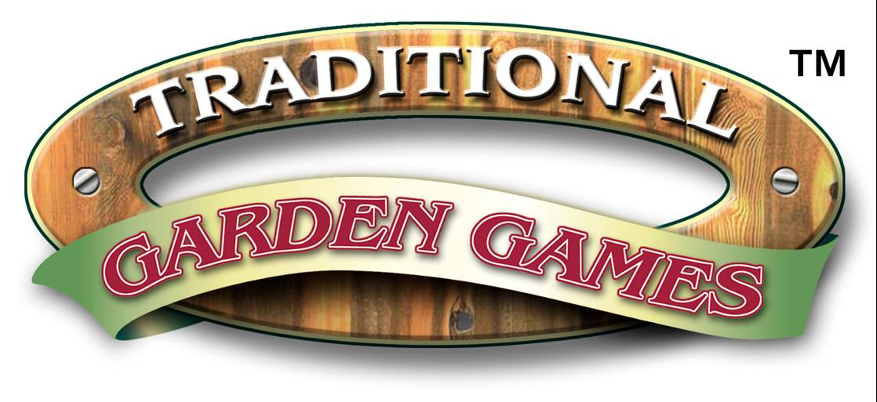

www,traditionalgardengames.co.uk

GB

NOUGHTS & CROSSES OR TIC TAC TOE AS IT IS CALLED IN DIFFERENT PARTS OF THE WORLD IS PROBABLY ONE OF THE EASIEST GAMES TO PLAY. ONE PLAYER USES THE X SYMBOL AND THE OTHER O. TAKING TURNS THE PLAYERS ALTERNATIVELY PUT AN X OR O IN AN EMPTY SPACE ON THE BOARD. THE OBJECT OF THE GAME IS SIMPLE FILL ANY ROW, VERTICALLY, HORIZONTALLY OR DIAGONALLY WITH 3 Xs OR 3Os AND YOU ARE THE WINNER

